2022-2023 MEMBERSHIP FORM
AWARE is dedicated to fighting Alzheimer’s disease by providing funding and support to programs, projects, and research provided by nonprofit organizations that actively help all individuals affected by Alzheimer’s in Dallas and the greater North Texas area.
To learn more, go to awaredallas.org

List my primary contact name as indicated below: (please print)

| Last Name First Name Spouse’s Name
□ No changes from last year’s directory

| __| | Address City State Zip

__| | Home Phone Business Phone Cell Phone

Email Address:
Information will be sent by email unless otherwise noted here: □U.S.P.S.

Please address social invitations as follows:
□ Mr. & Mrs.□ Dr. & Mrs. □ Dr. □ Mr. □ Mrs.□ Ms. □ Miss o Mr. and Dr.

□ Other: _

Membership Status: | □ Renewal | □ New Member
Membership Level: | □ Archangel $500 + | □ Angel $250 + | □ Caregiver $150 +
□ Regular $75 + | □ BvB Dallas $40 + | □ $500+ Corporate/Organization  (Please list up to six representatives.)

, ,

, ,

Enclosed is my check made payable to AWARE in the amount of $
You may join and pay your AWARE membership online at: www.awaredallas.org/join.

Please charge $ to my Credit Card # Expiration Date: Security Code:
Name on credit card:
Billing Address City State Zip Code
Signature:

Please see back of page for Volunteer and Referral Opportunities

Referrals: If you have a friend(s) interested in joining AWARE, please list their name(s) below:
Name | Address | City | State | Zip
Email |  | Phone
Name | Address | City | State | Zip
Email |  | Phone
I would like to volunteer my services with helping:

□ Programs □ Meetings/Arrangements/Hospitality □ AWARE Affair □ Special Events

□ Nametags □ Membership □ Communications/Network □ Directory

□ Underwriting □ Correspondence/Remembrances □ Marketing □ Hosting an Event

□ Other opportunities as needed

AWARE FOUNDERS, the BOARD, MEMBERS, DONORS, GRANT RECIPIENTS AND THOSE WE SERVE ARE GRATEFUL FOR YOUR CONTRIBUTION

THANK YOU

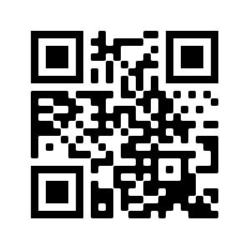
Click here to go to AWARE’s website!

PLEASE RETURN TO: AWARE, 25 Highland Park Village, Suite 100-485, Dallas, TX 75205
OR Join online at www.awaredallas.org

Your membership is tax deductible to the extent permitted by applicable law.
The Dallas Foundation, a 501(c)(3) publicly supported charity,
Federal Tax ID 75-2890371, is the fiscal sponsor of AWARE

